**Assignment -2**

Data Visualization and Pre-processing

|  |  |
| --- | --- |
| Assignment Date | 30 September2022 |
| Student Name | KALPIKA K |
| Student Roll Number | 111519104058 |
| Maximum Marks | 2 Marks |

**Question-1:**

## 1. Download the dataset: Dataset

|  |
| --- |
| **Solution:** |
| Downloaded succesfully |
|  |

**Question-2:**

## 2. Load the dataset.

|  |
| --- |
| **Solution:** |
| import pandas as pd  import numpy as np |

file=pd.read_csv("/content/Churn_Modelling (1).csv")

df=pd.DataFrame(file)

df.head()

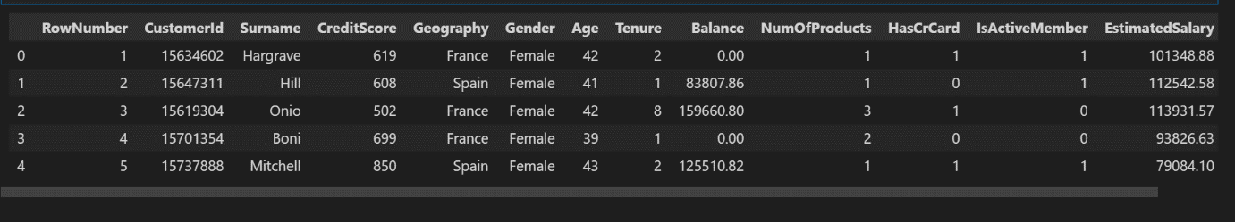

df['HasCrCard'] = df['HasCrCard'].astype('category')

df['IsActiveMember'] = df['IsActiveMember'].astype('category')

df['Exited'] = df['Exited'].astype('category')

df = df.drop(columns=['RowNumber', 'CustomerId', 'Surname'])

df.head()

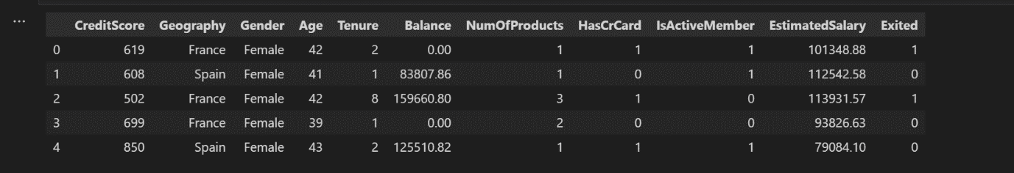

**Question 3:**

## 3. Perform Below Visualizations:

## Univariate Analysis, Bi - Variate Analysis, Multi - Variate Analysis

**Solution:**

import seaborn as sns

density = df['Exited'].value_counts(normalize=True).reset_index()

sns.barplot(data=density, x='index', y='Exited', );

density

|  |  |  |
| --- | --- | --- |
|  | index | Exited |
| 0 | 0 | 0.7963 |
| 1 | 1 | 0.2037 |



The data is significantly imbalanced

import matplotlib.pyplot as plt

categorical = df.drop(columns=['CreditScore', 'Age', 'Tenure', 'Balance', 'EstimatedSalary'])

rows = int(np.ceil(categorical.shape[1] / 2)) - 1

# create sub-plots anf title them

fig, axes = plt.subplots(nrows=rows, ncols=2, figsize=(10,6))

axes = axes.flatten()

for row in range(rows):

    cols = min(2, categorical.shape[1] - row*2)

    for col in range(cols):

        col_name = categorical.columns[2 * row + col]

        ax = axes[row*2 + col]

        sns.countplot(data=categorical, x=col_name, hue="Exited", ax=ax);

plt.tight_layout()

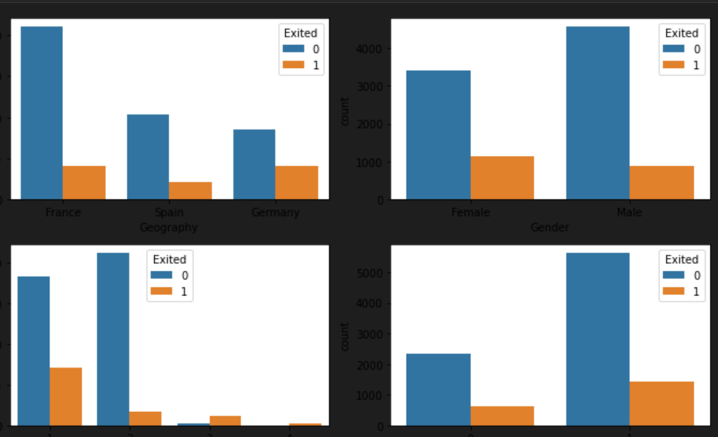

**Question 4:**

## 4. Perform descriptive statistics on the dataset.

**Solution:**

df.info()

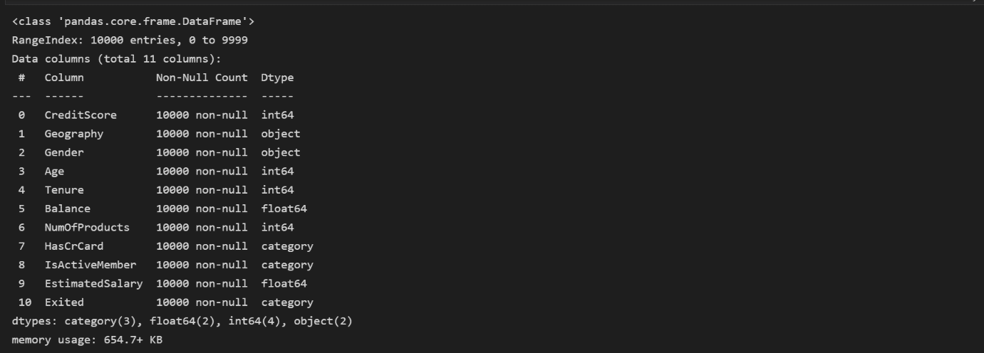

df.describe()



**Question 5:**

## 5. Handle the Missing values.

**Solution:**

df.isna().sum()

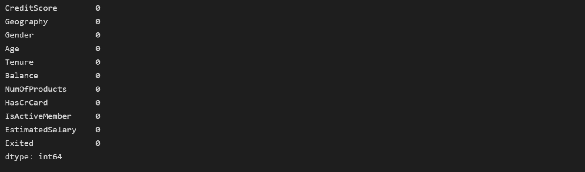

There is no missing values in dataset

for i in df:

    if df[i].dtype=='object' or df[i].dtype=='category':

        print("unique of "+i+" is "+str(len(set(df[i])))+" they are "+str(set(df[i])))

unique of Geography is 3 they are {‘France’,’Germany’,’Spain’}

unique of Gender is 2 they are {‘Male’,’Female’}

unique of Has CrCard is 2 they are {0,1}

unique of Is Active Member is 2 they are {0,1}

unique of Exited is 2 they are {0,1}

**Question 6:**

## 6. Find the outliers and replace the outliers.

**Solution:**

Checking for outliers

def box_scatter(data, x, y):

    fig, (ax1, ax2) = plt.subplots(nrows=2, ncols=1, figsize=(16,6))

    sns.boxplot(data=data, x=x, ax=ax1)

    sns.scatterplot(data=data, x=x,y=y,ax=ax2)

box_scatter(df,'CreditScore','Exited');

plt.tight_layout()

print(f"# of Bivariate Outliers: {len(df.loc[df['CreditScore'] < 400])}")

# of bivariate Outliers:19

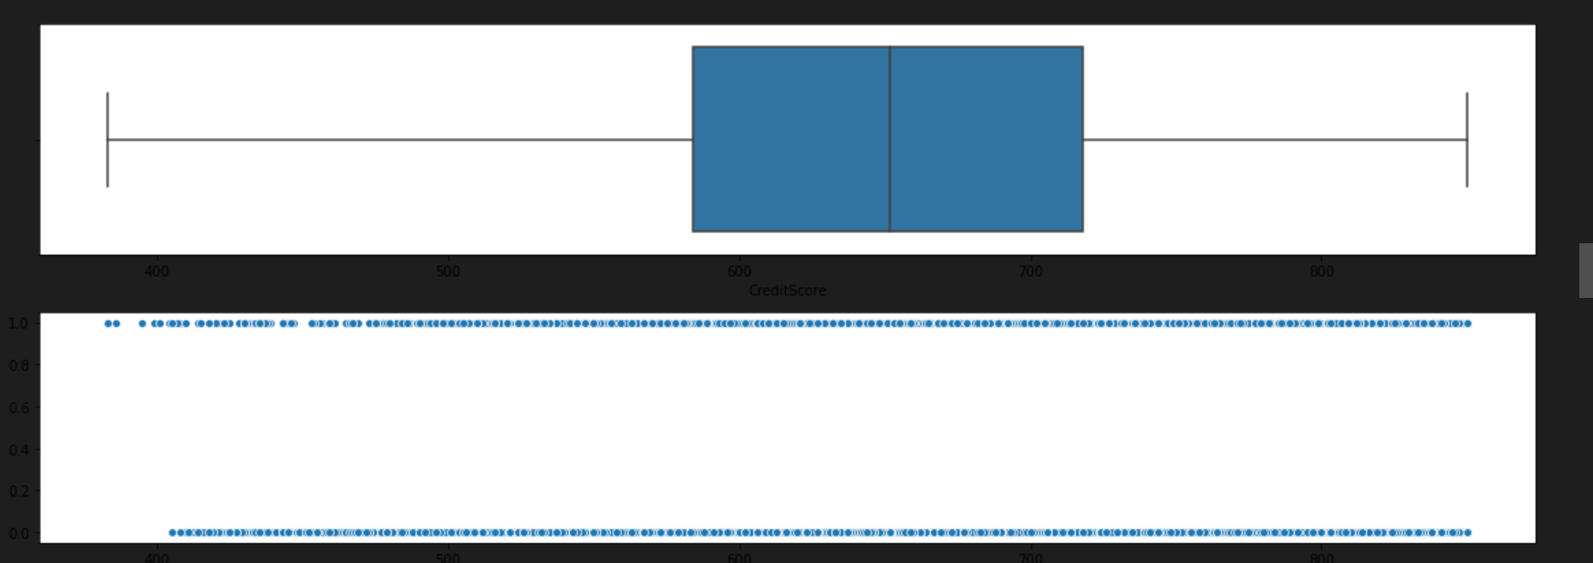

box_scatter(df,'Age','Exited');

plt.tight_layout()

print(f"# of Bivariate Outliers: {len(df.loc[df['Age'] > 87])}")

# of bivariate Outliers:0

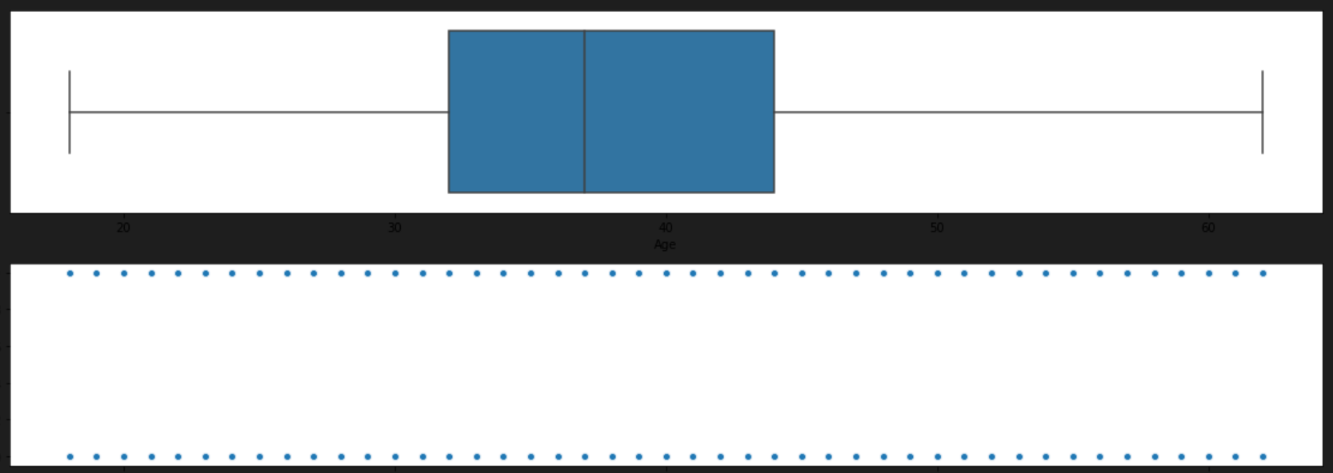

box_scatter(df,'Balance','Exited');

plt.tight_layout()

print(f"# of Bivariate Outliers: {len(df.loc[df['Balance'] > 220000])}")

# of bivariate Outliers:4

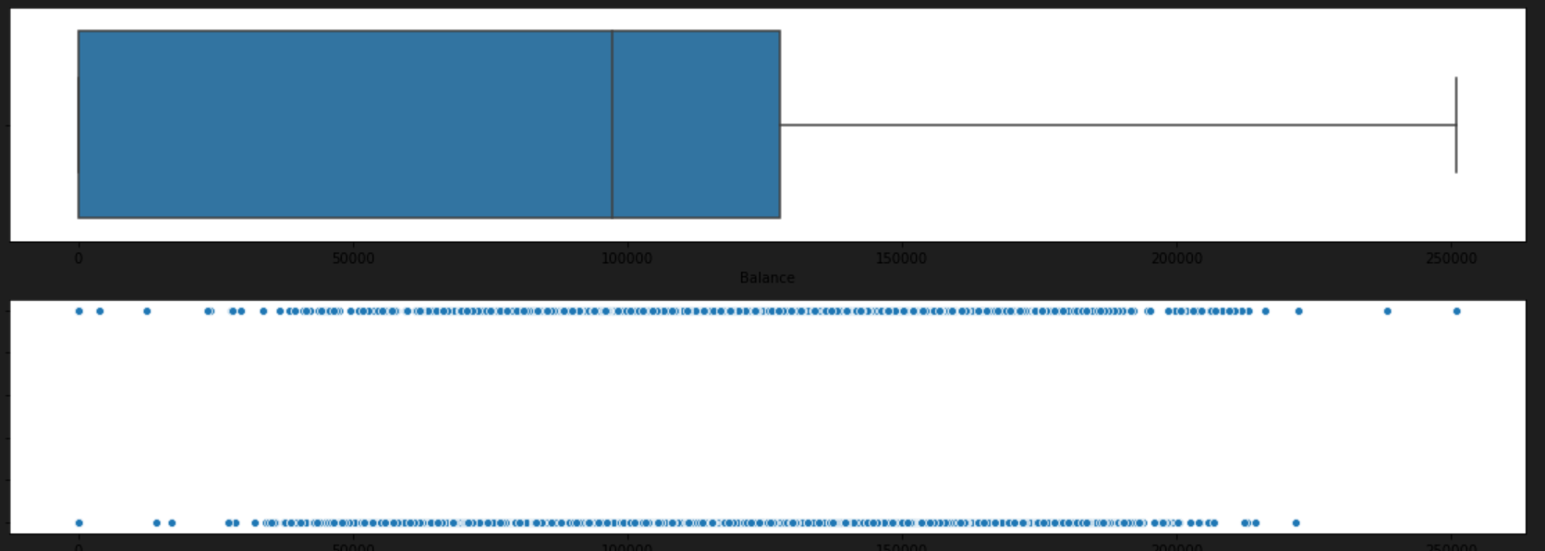

box_scatter(df,'EstimatedSalary','Exited');

plt.tight_layout()

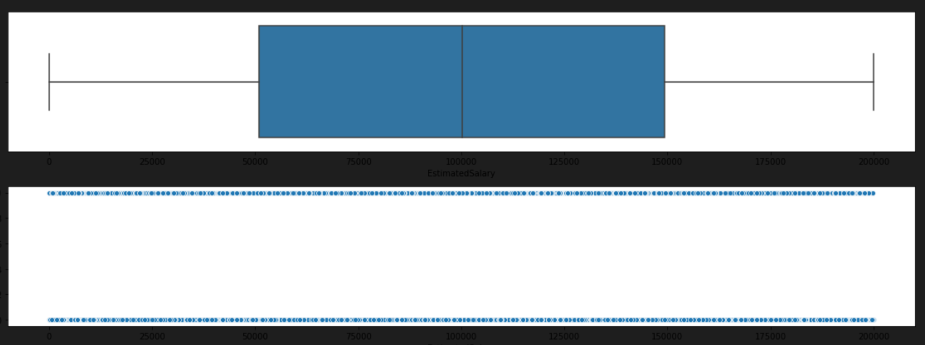

Removing Outliers

for i in df:

    if df[i].dtype=='int64' or df[i].dtypes=='float64':

        q1=df[i].quantile(0.25)

        q3=df[i].quantile(0.75)

        iqr=q3-q1

        upper=q3+1.5*iqr

        lower=q1-1.5*iqr

        df[i]=np.where(df[i] >upper, upper, df[i])

        df[i]=np.where(df[i] <lower, lower, df[i])

After removing outliers,boxplot will be like

box_scatter(df,'CreditScore','Exited');

plt.tight_layout()

print(f"# of Bivariate Outliers: {len(df.loc[df['CreditScore'] < 400])}")

# of bivariate Outliers:19

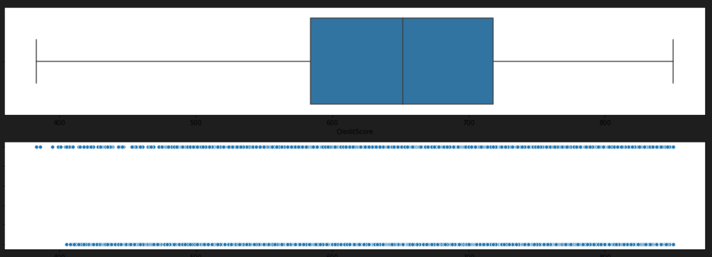

box_scatter(df,'Age','Exited');

plt.tight_layout()

print(f"# of Bivariate Outliers: {len(df.loc[df['Age'] > 87])}")

# of bivariate Outliers:0

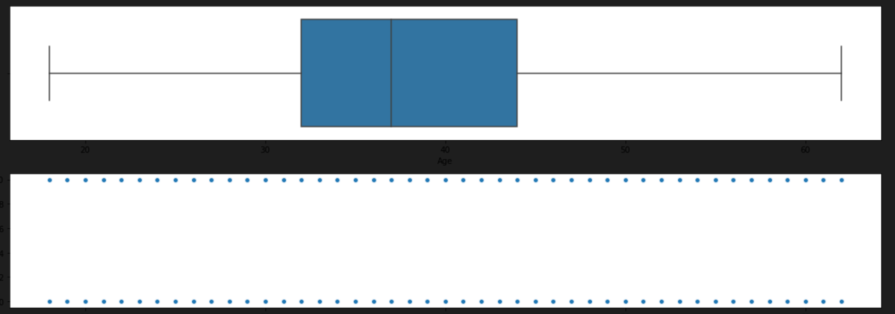

box_scatter(df,'Balance','Exited');

plt.tight_layout()

print(f"# of Bivariate Outliers: {len(df.loc[df['Balance'] > 220000])}")

# of bivariate Outliers:4

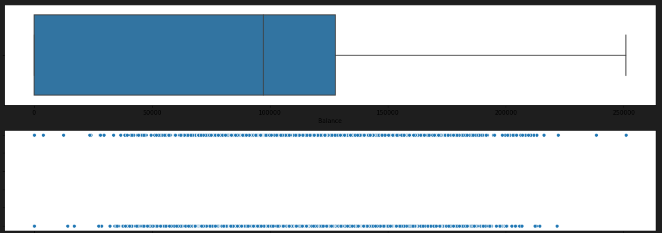

**Question 7:**

## 7. Check for Categorical columns and perform encoding.

**Solution:**

from sklearn.preprocessing import LabelEncoder

encoder=LabelEncoder()

for i in df:

    if df[i].dtype=='object' or df[i].dtype=='category':

        df[i]=encoder.fit_transform(df[i])

**Question 8:**

## 8. Split the data into dependent and independent variables.

**Solution:**

x=df.iloc[:,:-1]

x.head()

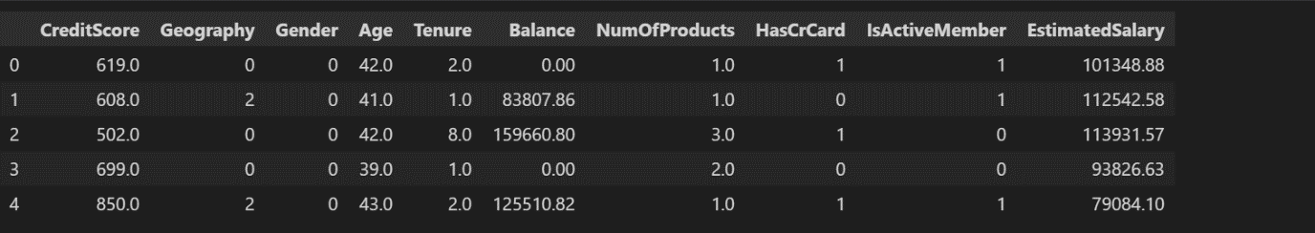

y=df.iloc[:,-1]

y.head()

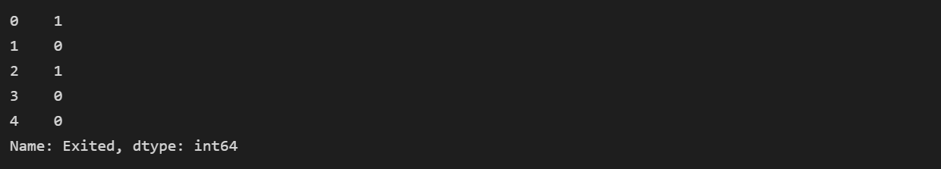

**Question 9:**

## 9. Scale the independent variables

**Solution:**

from sklearn.preprocessing import StandardScaler

scaler=StandardScaler()

x=scaler.fit_transform(x)

x

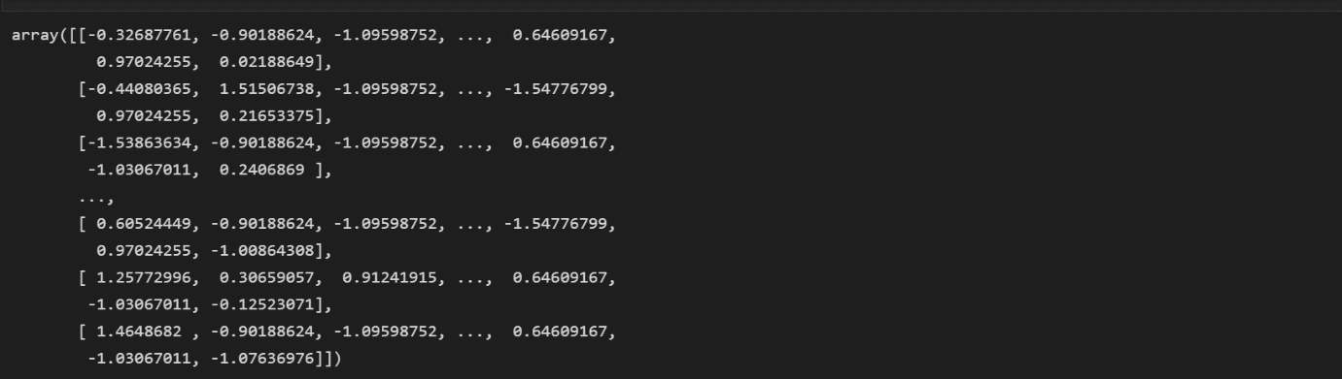

**Question 10:**

## 10. Split the data into training and testing

**Solution:**

from sklearn.model_selection import train_test_split

x_train,x_test,y_train,y_test=train_test_split(x,y,test_size=0.33)

